EXPERIMENT 7
INTEGRATING ZOHO CREATOR WITH ANOTHER ZOHO SERVICE USING CONNECTIONS AND APIs
Gym Membership Enrollment & Front Desk Management

Parikshith P
Reg. No: 2116241401062
Computer Science and Business Systems
Rajalakshmi Engineering College, Chennai

Aim
To integrate the Zoho Creator application, Gym Membership Enrollment & Front Desk Management, with Zoho CRM using Connections and Deluge scripting, and to verify the transfer of contact data to the CRM application.

Software Requirements
- Zoho Creator
- Zoho CRM
- Web browser and internet connection
- Deluge scripting environment

Description
Zoho Creator is a low-code application development platform that allows users to build business applications using forms, reports, workflows, and scripting. Zoho CRM is a customer relationship management platform used to manage contact information and customer interactions.
Connections allow Zoho Creator to securely communicate with other services after authorization. Deluge scripts can use these connections to perform operations such as retrieving or creating records in Zoho CRM.
In this experiment, a connection was configured between Zoho Creator and Zoho CRM. A Deluge script was used to create a test Contact record in Zoho CRM, and the record was verified in the CRM Contacts module.

Procedure

Step 1: Open the Zoho Creator Application
- Log in to Zoho Creator.
- Open the application named Gym Membership Enrollment & Front Desk Management.
- Navigate to the Microservices section from the development interface.
- Select Connections to configure the integration.
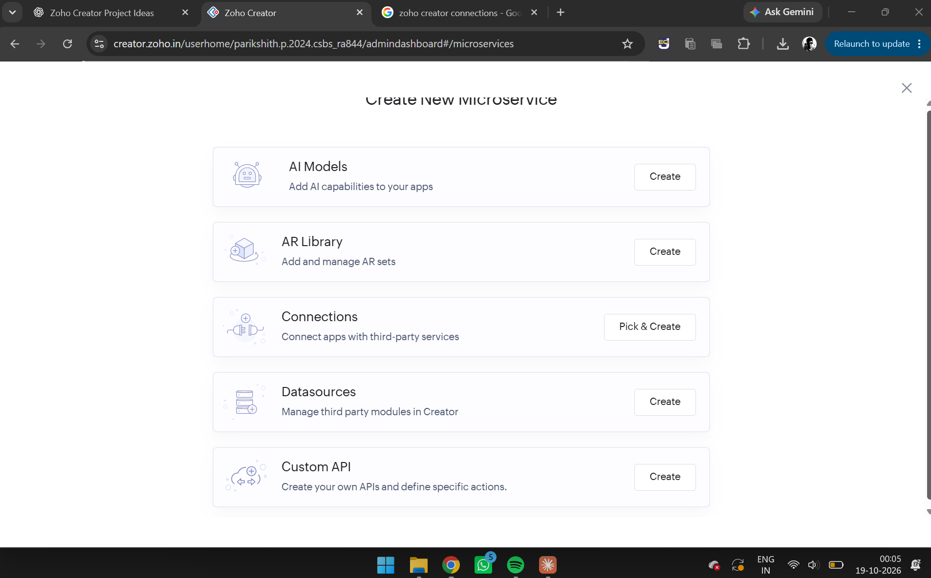
Figure 1. Zoho Creator Microservices page displaying the Connections option.

Step 2: Create a Zoho CRM Connection
- Click Pick & Create beside Connections.
- Select Zoho CRM from the available built-in connectors.
- Enter the connection name as Zoho CRM Connection.
- Select the available Zoho CRM version.
- Choose Administrators only for authorization access.
- Select Quick connect (Zoho credential).
- Click Create And Authorize.
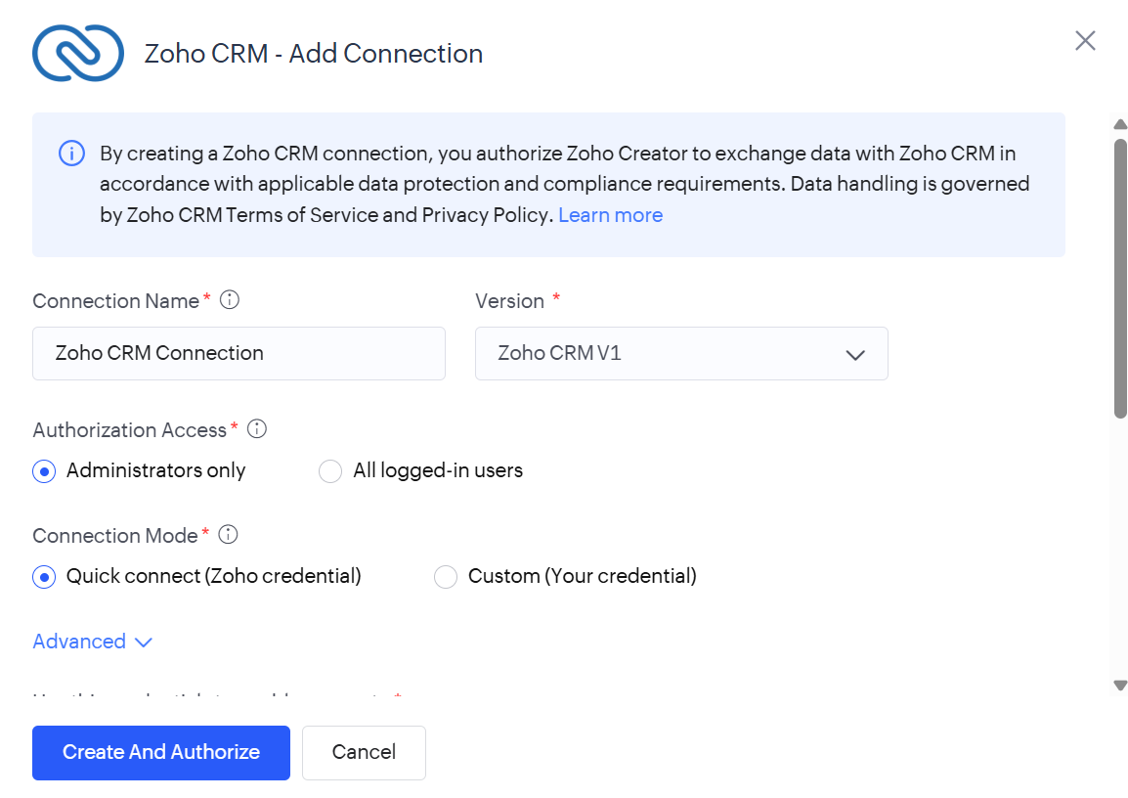
Figure 2. Zoho CRM – Add Connection configuration page.

Step 3: Authorize the Connection
- Sign in to the Zoho account associated with Zoho CRM.
- Review the requested permissions.
- Grant the required permissions where available.
- Complete the authorization process.
The connection was created with the link name:
zoho_crm_connection
This link name is used in the Deluge script to identify the connection.
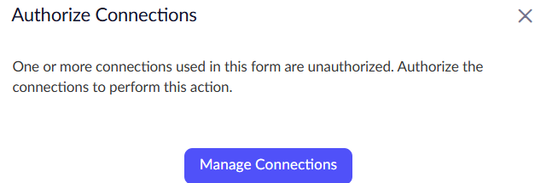
Figure 3. Authorize Connections prompt shown when the connection required authorization before use.
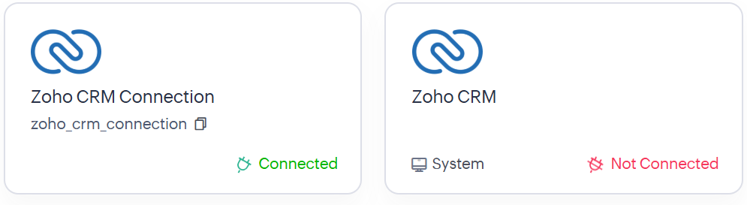
Figure 4. Zoho CRM authorization page showing the connection status after authorization.

Step 4: Enable Connection Access
- Open the created Zoho CRM Connection under Microservices.
- Locate the Connection Access section.
- Find the application Gym Membership Enrollment & Front Desk Management.
- Enable access for the application.
This allows the application to use the configured connection.
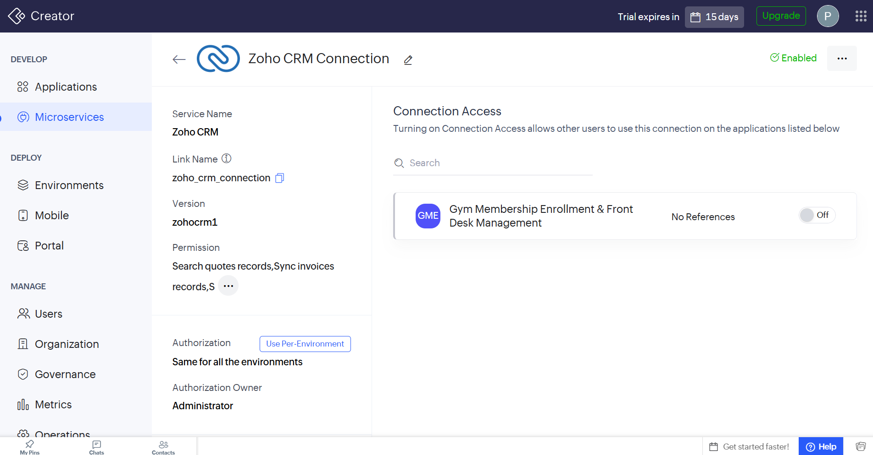
Figure 5. Connection details showing the connection link name, with application access not yet enabled.
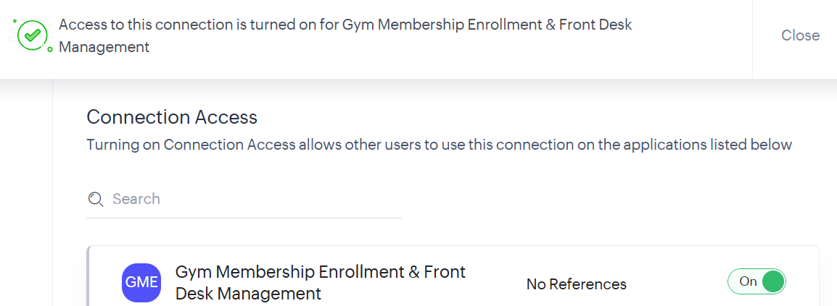
Figure 6. Connection Access enabled for the Gym Membership Enrollment & Front Desk Management application.

Step 5: Configure the Deluge Script
- Open the Gym Membership Enrollment & Front Desk Management application.
- Navigate to the workflow associated with the Membership Enrollment Form.
- Open the Deluge Script action.
- Use the Zoho CRM integration code to create a Contact record.
The existing age-validation script is retained separately to ensure that members below 18 years of age cannot submit the form.

Step 6: Deluge Code for Creating a CRM Contact
The following script creates a test Contact record in Zoho CRM using the configured connection.
contact = Map();
contact.put("Last_Name", "Gym Test Member");
contact.put("First_Name", "Creator");
contact.put("Email", "your_test_email@example.com");

response = zoho.crm.createRecord("Contacts", contact, Map(), "zoho_crm_connection");
info response;

Note: Replace your_test_email@example.com with a valid test email address before execution. The script must be placed in an appropriate post-submission workflow so that it runs after the membership record is saved.

Explanation of the Code
- contact = Map(); creates a map to hold the Contact field values.
- contact.put("Last_Name", "Gym Test Member"); sets the Contact's last name.
- contact.put("First_Name", "Creator"); sets the first name.
- contact.put("Email", "..."); assigns the email address.
- zoho.crm.createRecord() sends the Contact data to the Contacts module in Zoho CRM using the specified connection.
- info response; displays the API response for debugging and verification.

The connection was also verified directly from the Deluge editor using a Zoho CRM read operation, confirming that the zoho_crm_connection link was correctly wired into the workflow before the create-record script was executed.
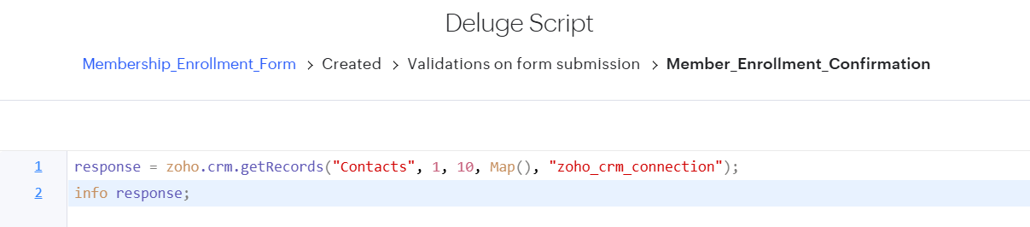
Figure 7. Deluge script in the Member_Enrollment_Confirmation workflow using the zoho_crm_connection connection to access Zoho CRM Contacts.

Step 7: Execute and Verify the Integration
- Save the Deluge script and workflow.
- Submit a test membership form with an age of 18 or above.
- Open Zoho CRM.
- Navigate to the Contacts module.
- Search for the test Contact named Creator Gym Test Member.
- Open the record to verify that the Contact was created.
The test Contact was visible in the Zoho CRM Contacts module, demonstrating that the record-creation operation succeeded.
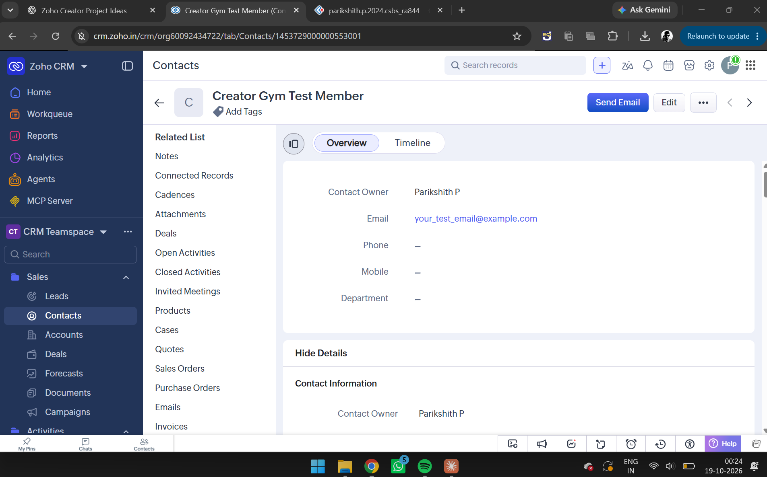
Figure 8. Zoho CRM Contacts page displaying the created test Contact, “Creator Gym Test Member.”

Output
The Zoho Creator application was connected to Zoho CRM using a configured connection. A test Contact named Creator Gym Test Member was created and verified in the CRM Contacts module.

Result
Thus, the integration of Zoho Creator with Zoho CRM using Connections and Deluge scripting was successfully demonstrated. A Contact record was created in Zoho CRM and verified in the Contacts module.

